ALL FIGURES AND TABLES

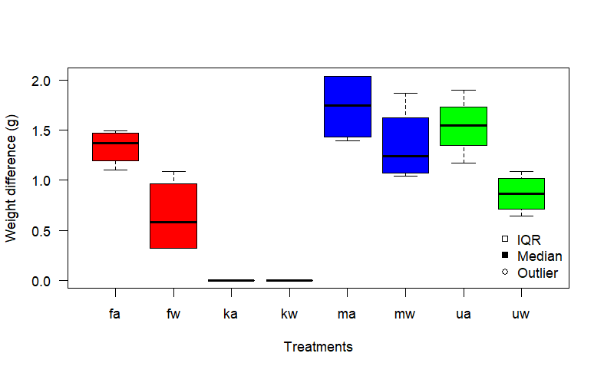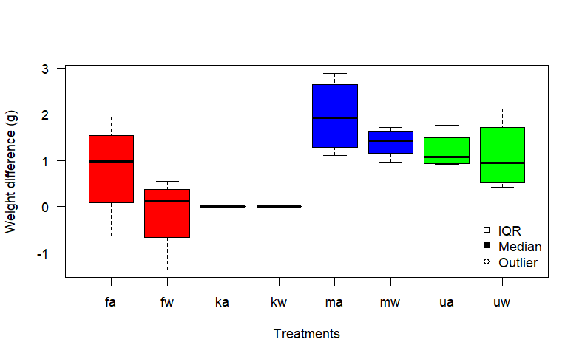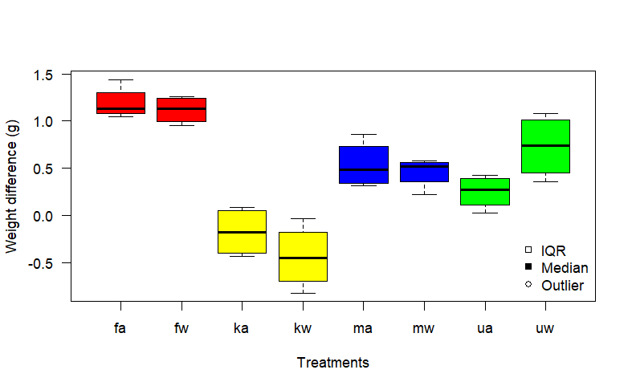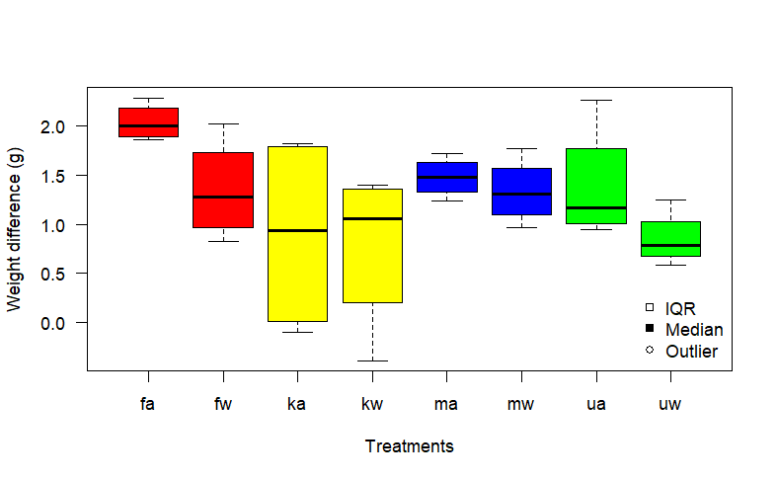

**a**

**b**

**c**

**d**

Figure : Boxplots of somatic growth in terms of weight (g) difference between measurement intervals.

a) T0 and T1 b) T1 and T2 c) T2 and T3 and d) T3 and T4

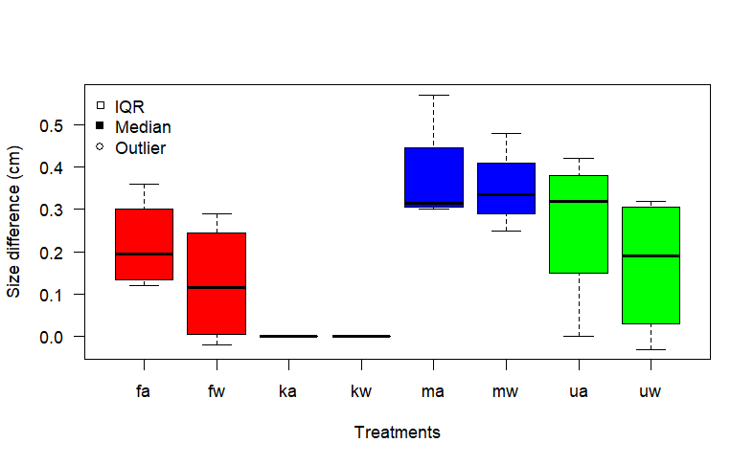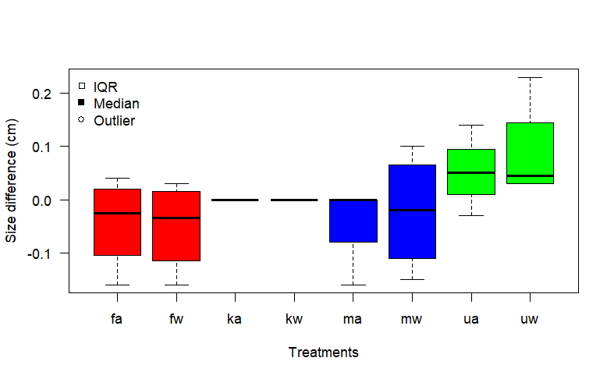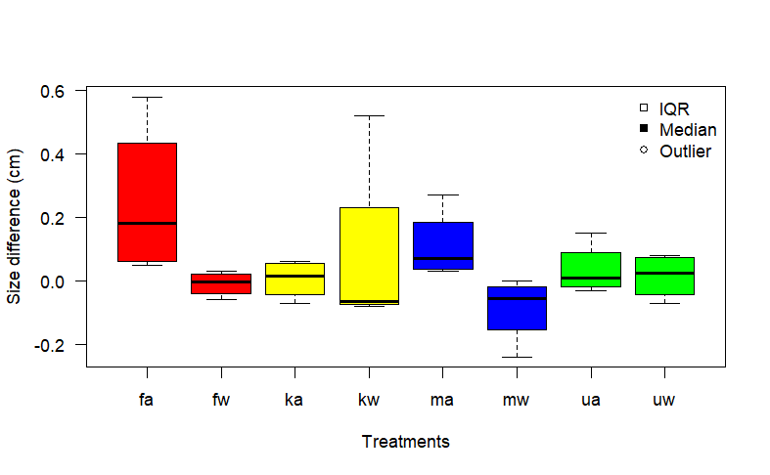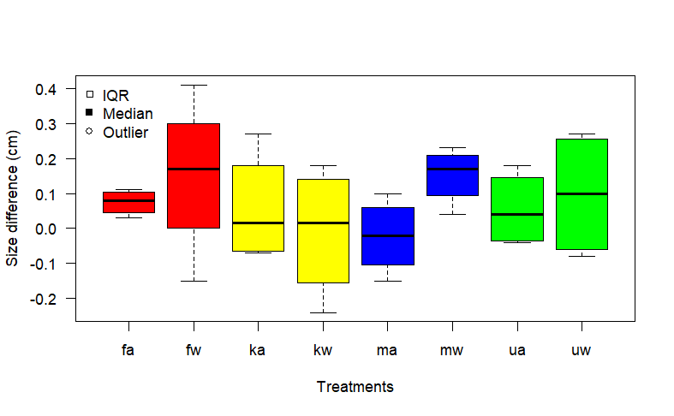

**a**

**b**

**c**

**d**

Figure 7: Boxplots of somatic growth in terms of size (cm) difference between measurement intervals.

a) T0 and T1 b) T1 and T2 c) T2 and T3 and d) T3 and T4